Production Analytics Agent



Prepared for Client X

Proposal for Tela for Production Analytics

Submission Date:
Confidentiality Statement
This document may contain information that is proprietary and confidential to SLB and/or a trade secret. SLB has provided this information solely for the purposes stated herein.
By continuing past this notice, you agree to keep the information confidential and to limit disclosure of the information to only those individuals within your organization who need to know the information. In addition, you agree not to: (I) disclose the information contained in this document to any third parties; (ii) use the information for any purpose other than to evaluate the suitability of a business relationship with Schlumberger; and (iii) use the information in any other way that might be detrimental to Schlumberger.

Copyrights and Trademarks
Copyright © 2024, SLB All rights reserved.
No part of this document may be reproduced, stored in a retrieval system or translated in any form or by means, electronic or mechanical, including photocopying and recording, without the prior written permission of SLB. SLB makes no warranties, express or implied, or statutory, with respect to the product(s) described herein and disclaims without limitation any warranties of merchantability or fitness for a particular purpose.
DELFI Petrotechnical Suite, DELFI Native Applications (e.g. DrillPlan, ProdOps…) Petrel, Techlog, Studio, Ocean, Omega, Drillbench, ECLIPSE, GeoX, GPM, IAM, InnerLogix, INTERSECT, Kinetix, Malcom, MEPO, Merak, OFM, OLGA, PetroMod, PIPESIM, ProSource, VISAGE, and Seabed are marks of SLB.
Agora and ModumGas are marks of SLB.
Other companies, product, and service names are the properties of their respective owners.

Conventions used in this document
SLB, Digital & Integration or SLB Technology Corporation may also be referred to as "D&I" or "Company"; and ONGC may also be referred to as “Client" or "Customer” in this document.
Validity: This proposal is valid for 90 days from the issue date.

Contacts
Name | Position | E-mail | Phone

Table of Contents

Executive Summary 5
Pilot Scope 8
Solution Architecture 9

Executive Summary
Generative AI has revolutionized how we interact with and extract value from complex, structured or unstructured data. By leveraging advanced natural language processing and machine learning, generative AI enables us to understand, interpret, and generate human-like responses based on diverse data sources, such as production data, technical documents, and other unstructured texts.
Agentic AI refers to autonomous, goal-driven AI systems capable of perceiving, reasoning, planning, and acting within complex environments—far beyond the linear, rule-based automation traditionally used in engineering workflows. Unlike standard automation, which breaks easily when data or conditions change, agentic AI adapts dynamically, orchestrates multi-step tasks, and collaborates with humans in the loop to deliver explainable, context-aware decisions.
Tela™ is SLB’s agentic-AI assistant and it is industry’s first agentic-AI assistant for Oil & Gas, enabling intuitive natural-language interaction, scalable deployment across cloud or on-prem configurations. It designed to bring unified experience to intelligence, automation, and domain-aware reasoning across the energy value chain. It represents a major leap in how digital products and workflows interact, combining AI-driven insights, advisor-level reasoning, and autonomous agent execution within a common experience. Tela is powered by the Lumi™ data and AI platform, ensuring security, scalability, and integration across SLB’s digital ecosystem.
Some of the common information which Production engineers require for their day-to-day tasks can be manager better using Agentic Solutions. They offer a range of features that differentiate them from traditional solutions. These features include:
- Conversation in natural language in most languages in the world
- Brings down the training barrier by giving insights based on product manuals and Engineered AI

Avocet
Avocet is renowned for its robust data management and production monitoring capabilities. With the integration of Generative AI, it transforms raw data into actionable insights and enables clients to harness data-driven strategies, maximizing operational efficiency and productivity.

Below is the list of reference questions Tela agent can answer for Avocet customers in natural language:

- What are the historical production rates for well X?
- Can you show me the allocated rates for the field “X” for the past month?
- Can you show me the allocated rates for well “X” for the past month?
- What is the latest well test for well X?
- Summarize well tests conducted in the last 3 months (conducted vs validated vs Rejected)
- Can you provide a shortfall analysis for our current production?
- How does the production forecast look for the next quarter for field X?
- What are the recent workover data captures?
- Can you summarize the production data that can be used in OFM analysis?
- Summarize/plot allocation factor / Field factor in last 6 months
- Show me the list of wells which became inactive / offline / shut-in in last 3 months
- what is the top candidate for production well test?
- Show me the list of wells with increasing water cut trend
- Show me the list of wells with increasing GOR trend
- Show me the list of wells with decreasing oil rate

OFM (Oil Field Manager)
OFM is the go-to tool for reservoir and production engineers to manage and optimize oil field performance by analyzing historical production. The integration of Generative AI in OFM elevates its analytical capabilities by delivering precise forecasts, identifying potential issues before they arise, and offering intelligent solutions for field development. This increased accuracy and reliability makes it indispensable for reservoir management and performance optimization.

Below is the list of reference questions Tela agent can answer for OFM customers in natural language:

- Can you show me the production variance for well X over the last month?
- Summarize / Plot waterflood KPIs for field Y?
- How is nearest injector affecting production from well Z?
- Can you provide a summary of the production / injection performance for the past week?
- What are the current production and injection rates for asset A?
- Can you analyse the field data for xx well and identify any anomalies?
- Explain the latest trends in production data.
- Can you calculate remaining reserves for field B and provide forecast for next x months?
- Summarise reservoir wise production and injection for field X
- Show the summary of reservoir with VRR <1, =1 and >1
- Plot reservoir pressure, production and injection over time for all the producing reservoir in field X
- Can you generate Heterogeneity Index plot for group of wells?
- Can you do Type well analysis for a group of wells and calculate the average P10 / 950/P90. I want to compare how well X is doing with respect to these type wells.
- I see high water production in well X. Can you run Chan analysis to confirm whether there are any chances of channelling or conning.

Solution screenshots are given below for reference:

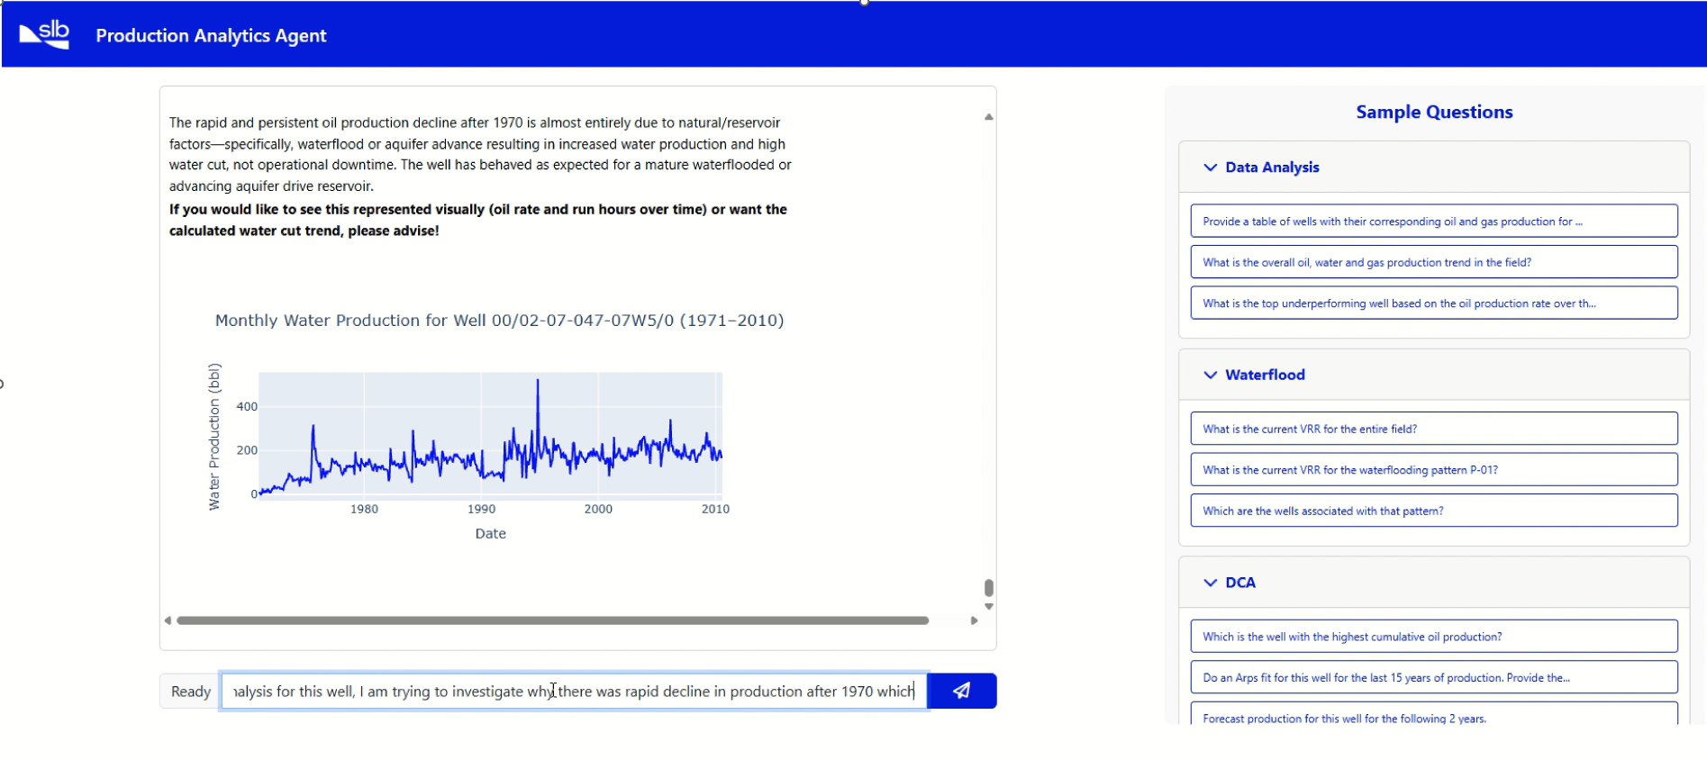
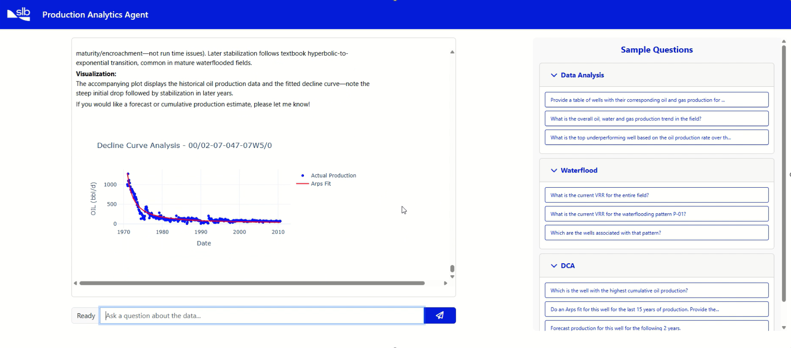
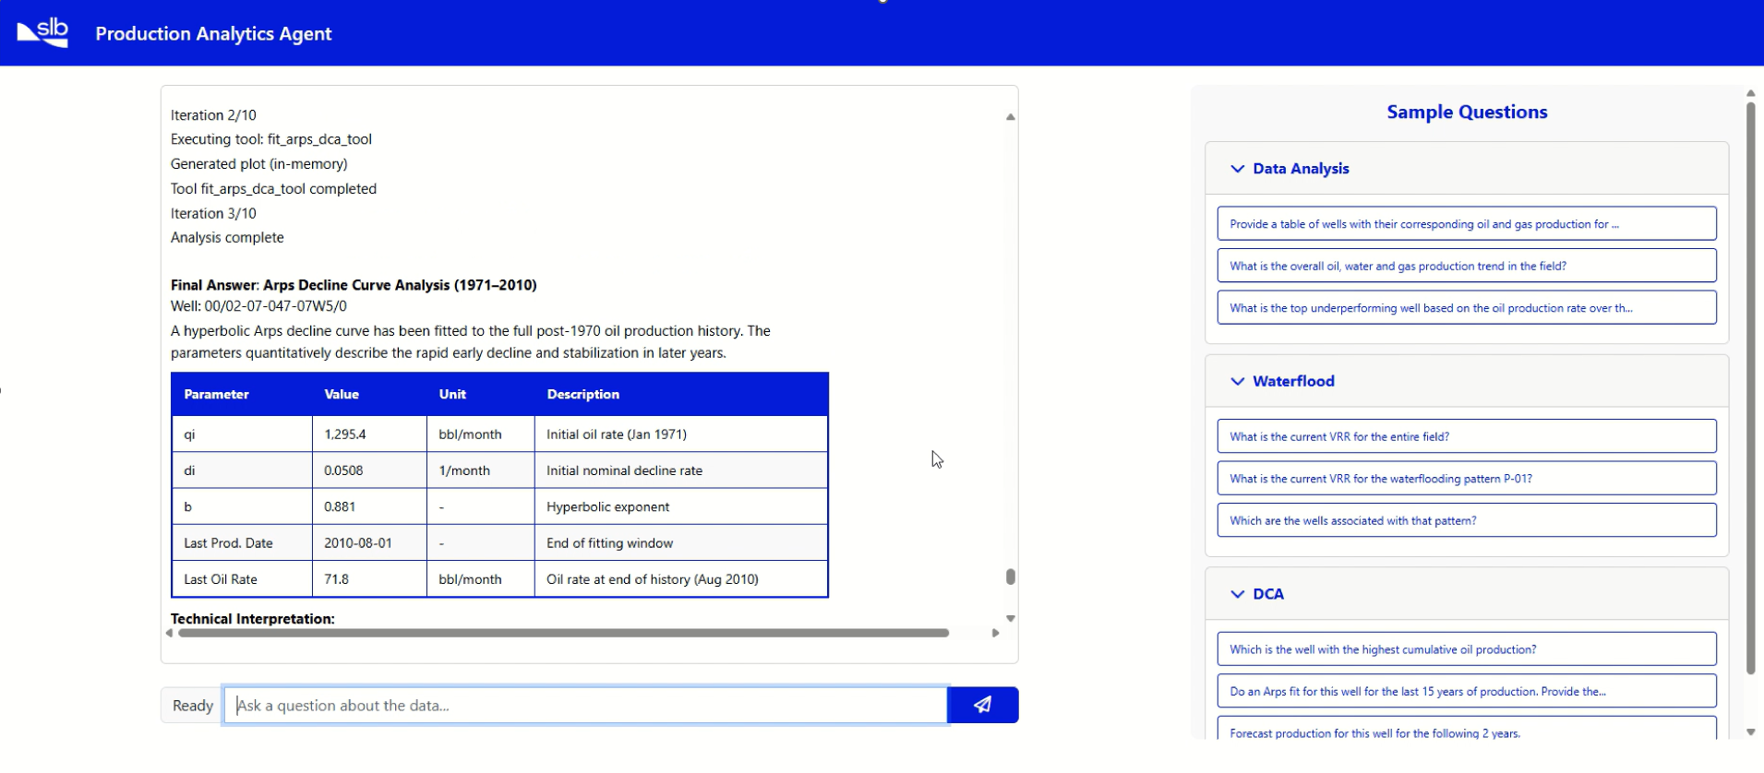

Pilot Scope
The Pilot scope includes Production Analytics Agent on top of OFM/Avocet. It will enable conversation in natural language with Production data in OFM/Avocet. As part of the conversation user will also be able to trigger forecasting workflow or decline curve analysis. The insights encompass details about historical production allocation /shortfall data from Avocet and Production/ reservoir / waterflood data from OFM.

For example, it will cover questions like:
OFM:
- Can you show me the production data for well X over the last month?
- What is the VRR of reservoir X / Pattern X?
- How many wells are there in Pattern X?
- How is nearest injector affecting production from well Z?
- Can you provide a summary of the production / injection performance for the past week?
- What are the current production and injection rates for asset A?
- Can you analyse the field data for xx well and identify any anomalies?
- Explain the latest trends in production data.
- Summarise reservoir wise production and injection for field X
- Show the summary of reservoir / Patterns with VRR <1, =1 and >1
- Plot reservoir pressure, production and injection over time for all the producing reservoir in field X
- Can you run the forecast for Well X
- Can you run the forecast for all the wells which are part of pattern X
- Can you provide me forecast for a well / group of wells for next 6 months?

Avocet:

- What are the historical production rates for well X?
- Can you show me the allocated rates for the field “X” for the past month?
- Can you show me the allocated rates for well “X” for the past month?
- What is the latest well test for well X?
- Summarize well tests conducted in the last 3 months (conducted vs validated vs Rejected)
- Can you provide a shortfall analysis for our current production?
- How does the production forecast look for the next quarter for field X?
- What are the recent workover data captures?
- Summarize/plot allocation factor / Field factor in last 6 months
- Show me the list of wells which became inactive / offline / shut-in in last 3 months
- what is the top candidate for production well test?
- Show me the list of wells with increasing water cut trend
- Show me the list of wells with increasing GOR trend
- Show me the list of wells with decreasing oil rate

Solution will be deployed using SLB’s Lumi AI Foundation. Detailed architecture will be provided based on discussions with ONGC.

Solution Architecture
Below is the generic solution architecture of the solution, where Production Analytics and other Tela agents can be enabled on top of OFM using Lumi AI Foundation. Depending on the client’s requirements, solution can be deployed using cloud or On. Prem. Or hybrid Architecture

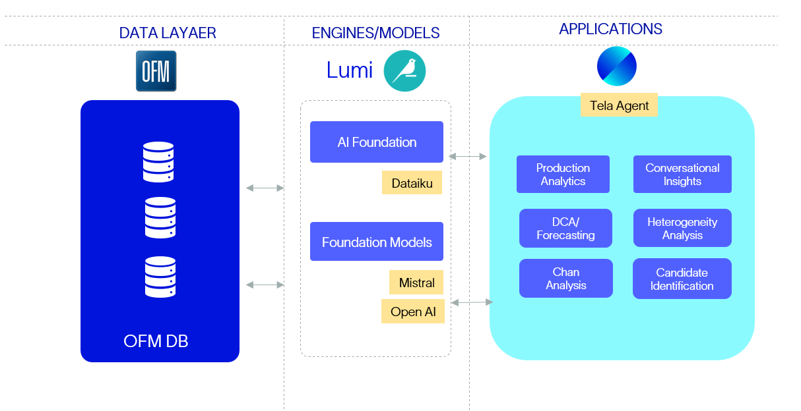

On. Prem. Architecture is given below for reference:
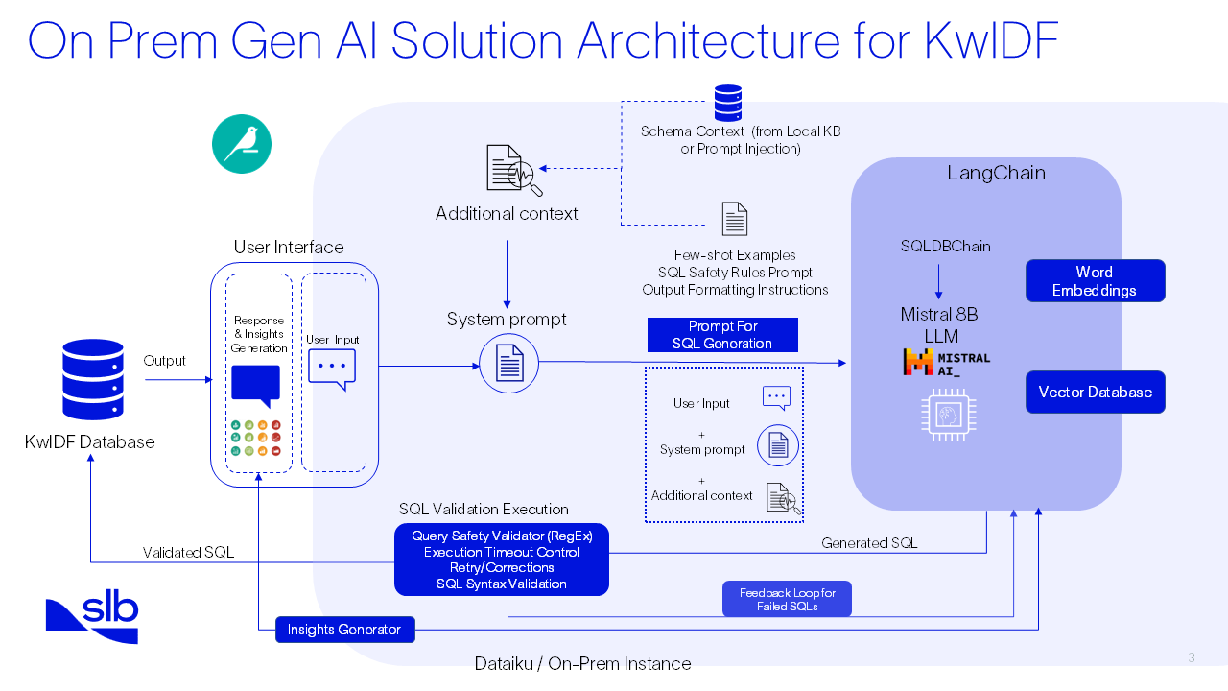
high-level architecture of the on-Premises agents with MISTRAL AI (On-Premises)

